

**ASSIGNMENT FRONT SHEET**

**Course Name: ALY6010 71904 Prob Theory and Intro Stats**

**Professor Name: Dr. Morteza Ziyadi**

**Student Name: Dong Quoc Tuong (Lukas)**

**Student Class: Fall 2019 CPS Term: A. 2019**

|  |
| --- |
| **Module 2 Project: Elementary Probability: Frequentist versus Bayesian**  **Completion Date: October 1st Word Count:891 Due Time:12:00am** |

**Statement of Authorship**

*I confirm that this work is my own. Additionally, I confirm that no part of this coursework, except where clearly quoted and referenced, has been copied from material belonging to any other person e.g. from a book, handout, another student. I am aware that it is a breach of Northeastern University’s regulations to copy the work of another without clear acknowledgement and that attempting to do so renders me liable to disciplinary procedures. To this effect, I have uploaded my work onto Turnitin and have ensured that I have made any relevant corrections to my work prior to submission.*

**Tick here** to confirm that your paper version is identical to the version submitted through Turnitin

1. **Introduction**

The report below demonstrates the probability the quality manufacturing company selected the projects that suit their requirements out of the sample of 50. It includes the mathematical notation, the formula, analysis and potential recommendations that quality control manager can use to improve performance of all projects.

1. **Analysis**

**Graph 1**

To calculate the “Notation for the Probability” for each of the event Q,S and C happens is exactly them only. To calculate the frequency for each of them, we will use countifs() function in Excel for with the condition for each of those specific events to happen and nothing else. Then the Probability/ Percentage is calculated by dividing the Frequency that event Q,C or S happens to the total number of the samples. Keeping in mind that these scenarios are not independent so when you add everything together, the result will be more than 1, which is different from the next part.

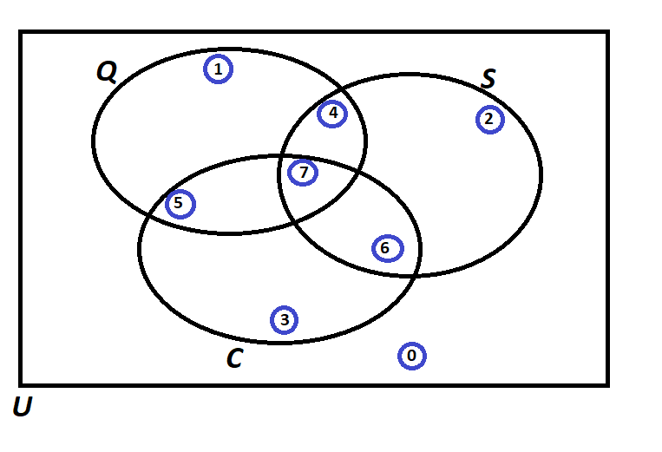

**Graph 2**

After we calculate all the probability for graph 2, the sum of all 1-8 probabilities will equal 1.

* Scenario 0: The probability of Scenario 0 happens is the intersection between all the complements of Quality, Speed and Cost. We just only want the part that is outside of the Q,S and C altogether. For frequency, Countifs() for all the Q,S,C events to not happen
* Scenario 1-3: The probabilities of Scenario 1-3 happen are the intersections between the Quality, Speed and Cost scenarios with the complements of the other two scenarios respectively. For example, (1) would be the intersection between Q and complements of S and C. For frequency, Countifs() for event that specific Q,S or C happen but not the other two
* Scenario 4-6: The probabilities of Scenario 4-6 happen are the intersections between the Quality+Speed, Quality+Cost and Speed+Cost scenarios with the complements of the other Cost, Speed and Quality respectively. For example, (4) would be the intersection between Q,S and complements of C. For frequency, Countifs() for event that specific 2 events happen but not the third one.
* Scenario 7: The probability of Scenario 0 is the intersection between Quality, Speed and Cost requirements, nothing more. For frequency, Countifs() for event that all three events to happen.

All the Probability formulas for table 2 would be: $P()= \frac{Scenarios' frequencies }{Total sample size \left(50\right)}$

**Graph 3**

The next graph, each of these requests is different from each other so there is no point in finding the sum for them together:

* Scenario a/b : The probability of Scenario a/b happens is the conditional probability of S/C given to C/Q occurs. For frequency, Countifs() for all the C/C and S/Q happen at the same time but not C/S.
$$P\left(S | C\right) or P(C|Q)=\frac{Scenarios' frequencies }{Frequencies that S/Q happen }$$

* Scenario c/d : The probability of Scenario c/d happens is the conditional probability of S and C’/Q’ given to Q/C occurs. For frequency, Countifs() for all the S and Q/C happen at the same time but not C/Q.
$$P( S ∩ C'|Q)=\frac{Scenarios' frequencies }{Frequencies that Q happen }$$

* Scenario e : The probability of Scenario e happens is the conditional probability of S and Q’ given to C occurs. For frequency, Countifs() for all the Q and C happen at the same time but not S.
$$P( Q ∩C |S')=\frac{Scenarios' frequencies }{Frequencies that C happen }$$

* Scenario f : The probability of Scenario f happens is to find the sum of all the Probability for Scenario 4-6 happen. The frequency of scenario f equals to the total of frequencies for scenarios for 4-6 happen.
$$P(Q ∩ S ∩ C')+P(Q ∩ S' ∩ C)+P(Q' ∩ S ∩ C)=\frac{Total frequencies of Scenarios 4,5,6 }{Total sample size (50) }$$

* Scenario g : The probability of Scenario g happens is to subtract the probability of Q intersects C and probability of Q intersect C intersect S’ from the probability of the union of Q,S,C. The frequency of scenario g equals to the total of frequencies for scenarios for 1-3 happen.
$$P(Q U S U C)- P( Q U C) - P( Q U C U S' ) =\frac{Total frequencies of Scenarios 1,2,3}{Total sample size \left(50\right)-Frequencies that scenario 0 happens}$$

* Scenario h : The probability of Scenario h happens is the conditional probability of S given to C-complement occurs. For frequency, Countifs() for all the S happen but not C.

$$P( S | C') =\frac{Scenarios' frequencies }{Total sample size \left(50\right)-Frequencies that C happens }$$

In general, workers are doing very well in term creating high-quality products, given to the high number of projects that passed the “Quality” test. The total numbers of projects that satisfy “Speed” (22) are lower than any other groups which mean that they need to care more about the duration of the projects if they want to boost productivity. The Probability of projects that do not qualify for any Q,S or C (0) is 12%,just a little bit lower than the average probability for all scenarios from 0-7 (13%). On the other hand, Scenario 3 is significantly lower (8%). The company can decrease the number of totally unqualified projects by just focusing more on reducing cost through “Program of Predictive Maintenance”. (“How to reduce operational costs while meeting increased customer demands,” 2018)

1. **Conclusion**

In conclusion, the control manager needs to focus more on other attributes rather than just Quality. Researchers are required to carry out more in-depth research before drawing any conclusion for this population.

**References**

How to reduce operational costs while meeting increased customer demands. (2018). Retrieved from https://www.williamsonir.com/blog/reduce-production-cost-manufacturing/